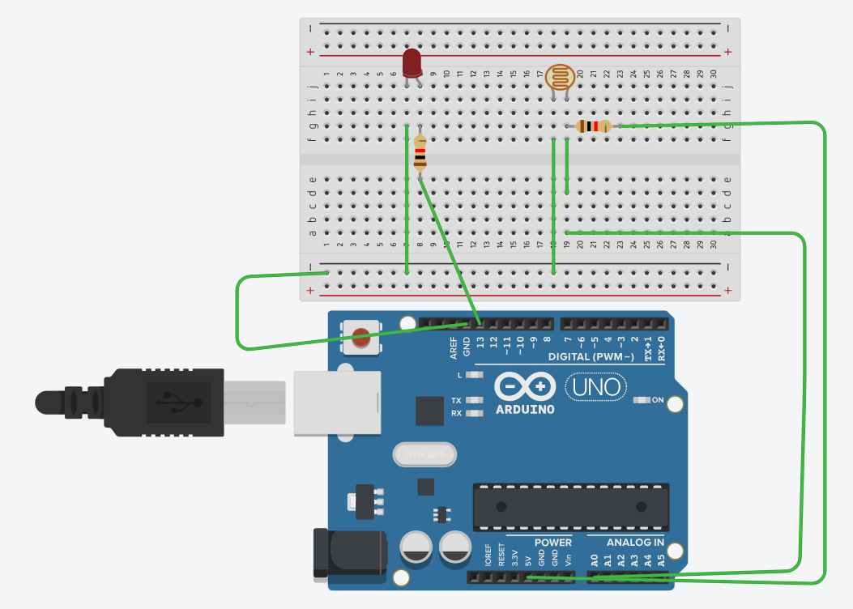
const int ldrPin = A0;
const int ledPin = 13;
int threshold = 500; //adjust: 0 (bright) .. 1023 (dark)
void setup() {
pinMode(ledPin, OUTPUT);
Serial.begin(9600);
}
void loop() {
int val = analogRead(ldrPin);
Serial.println(val);
if (val > threshold){
digitalWrite(ledPin, HIGH);
}
else {
digitalWrite(ledPin, LOW);
}
delay(200);
}

